Objectives for Real Sector Statistics
Strengthen methodologies, accuracy, and timely dissemination of national accounts and price statistics.

About AFRITAC South (AFS)
The IMF’s Regional Technical Assistance Centers work in collaboration with the IMF, beneficiary countries, and development partners to (i) strengthen human and institutional capacity to design and implement policies that promote inclusive growth, and (ii) help countries advance on the Sustainable Development Goals (SDGs).
Since October 2011 AFS has provided Technical Assistance (TA) and training to Angola, Botswana, Comoros, Lesotho, Madagascar, Mauritius, Mozambique, Namibia, Seychelles, South Africa, Swaziland, Zambia, and Zimbabwe. It works closely with several IMF departments.

Main Achievements Since 2011

Better macroeconomic statistics are essential in the formulation and impact assessment of policies and to measure progress against the related SDGs.

Key achievements include the adoption of updated systems of national accounts, the introduction of a new benchmark year, the rebasing of GDP, extension of the scope of national accounts and improvement in source data, the revision of consumer price index (CPI) weights, and the development of producer price indices (PPI).

- Six countries updated their systems of national accounts
- The average benchmarking year for national accounts was updated from 1998 to 2009
- Four additional countries produce quarterly GDP in volumes
- Five countries improved the coverage of the CPI
- Two additional countries produce a PPI

Improving National Accounts

New benchmarks provide a better picture of the size and structure of the economy. Angola, Lesotho, Madagascar, Mozambique, Namibia, Seychelles, Swaziland, and Zambia will rebase national accounts before 2020.
Rebasing is the opportunity to improve data sources and methodologies. Most countries will be using the System of National Accounts 2008 by 2020.
Quarterly GDP enables early identification of turning points in the economy and supports better decision-making and forecasting. Angola, Lesotho, Madagascar, Namibia, Swaziland will develop or extend quarterly GDP by 2019.
Advanced developments are underway in Special Data Dissemination Standard (SDDS) countries such as South Africa to improve of seasonal adjustment methods or in Mauritius to enhance financial accounts and balance sheets.

Expanding and Improving Price Statistics

Botswana, Lesotho, Madagascar, Namibia, Swaziland, and Zambia will rebase their CPI before 2020. Current weights improve the measure of inflation.
Angola, Lesotho, Namibia, Swaziland, and Zambia will develop PPI or import and export price indices by 2020.

Institutional Strengthening and Coordination

AFS supports strategic planning and institutional strengthening by contributing to the development of national strategies for the development of statistics and by providing strategic advice. A seminar for the managers of macroeconomic statistics has been prepared. AFS TA also contributes to countries’ graduation from the IMFs’ General Data Dissemination System (GDDS) to SDDS.
AFS coordinates TA with development partners including the World Bank, the African Development Bank, the International Labour Organization, the Common Market for Eastern and Southern Africa, and the Southern African Development Community.

Statement by Mr. Samuel Randriambolamanitra,
Director of Macroeconomic Statistics at the National Statistical Institute of Madagascar:
“The technical assistance from AFRITAC South has helped us adopt the System of National Accounts. Madagascar has recently compiled supply-use tables for the new base year 2007 …
The professional attachment [funded by AFRITAC South] of several national accountants from Madagascar to Statistics Mauritius has provided them with a better understanding of the compilation process …
Assistance from AFRITAC South has helped us deepen our understanding of national accounts concepts …”

Contact Information
E-mail: staremail@imf.org
afsweb@imf.org
 | http://www.southafritac.org/  https://www.facebook.com/AfritacSouth/
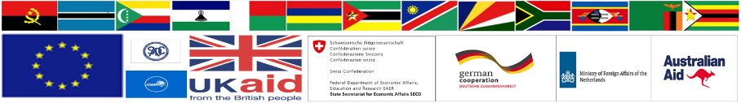

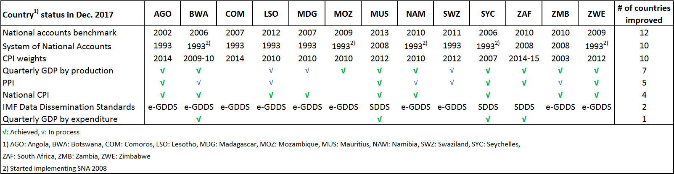
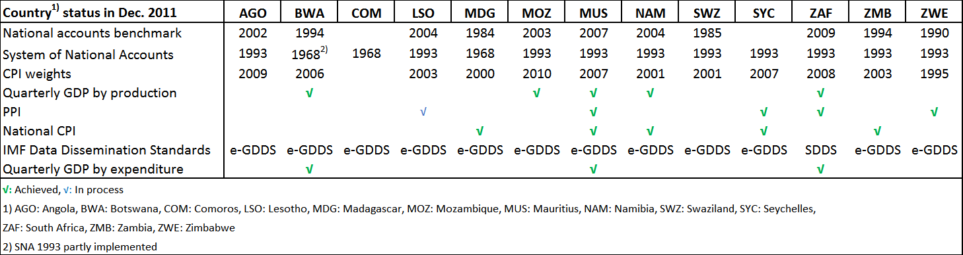
South Africa Regional Status of Real Sector Statistics (December 2017) - After
South Africa Regional Status of Real Sector Statistics (December 2011) - Before

Project to Improve Real Sector Statistics in The IMF’s Regional Technical Assistance Center for Southern Africa
AFRITAC SOUTH



AFRITAC SOUTH
and
Statistics Department
INTERNATIONAL MONETARY FUND
2018

